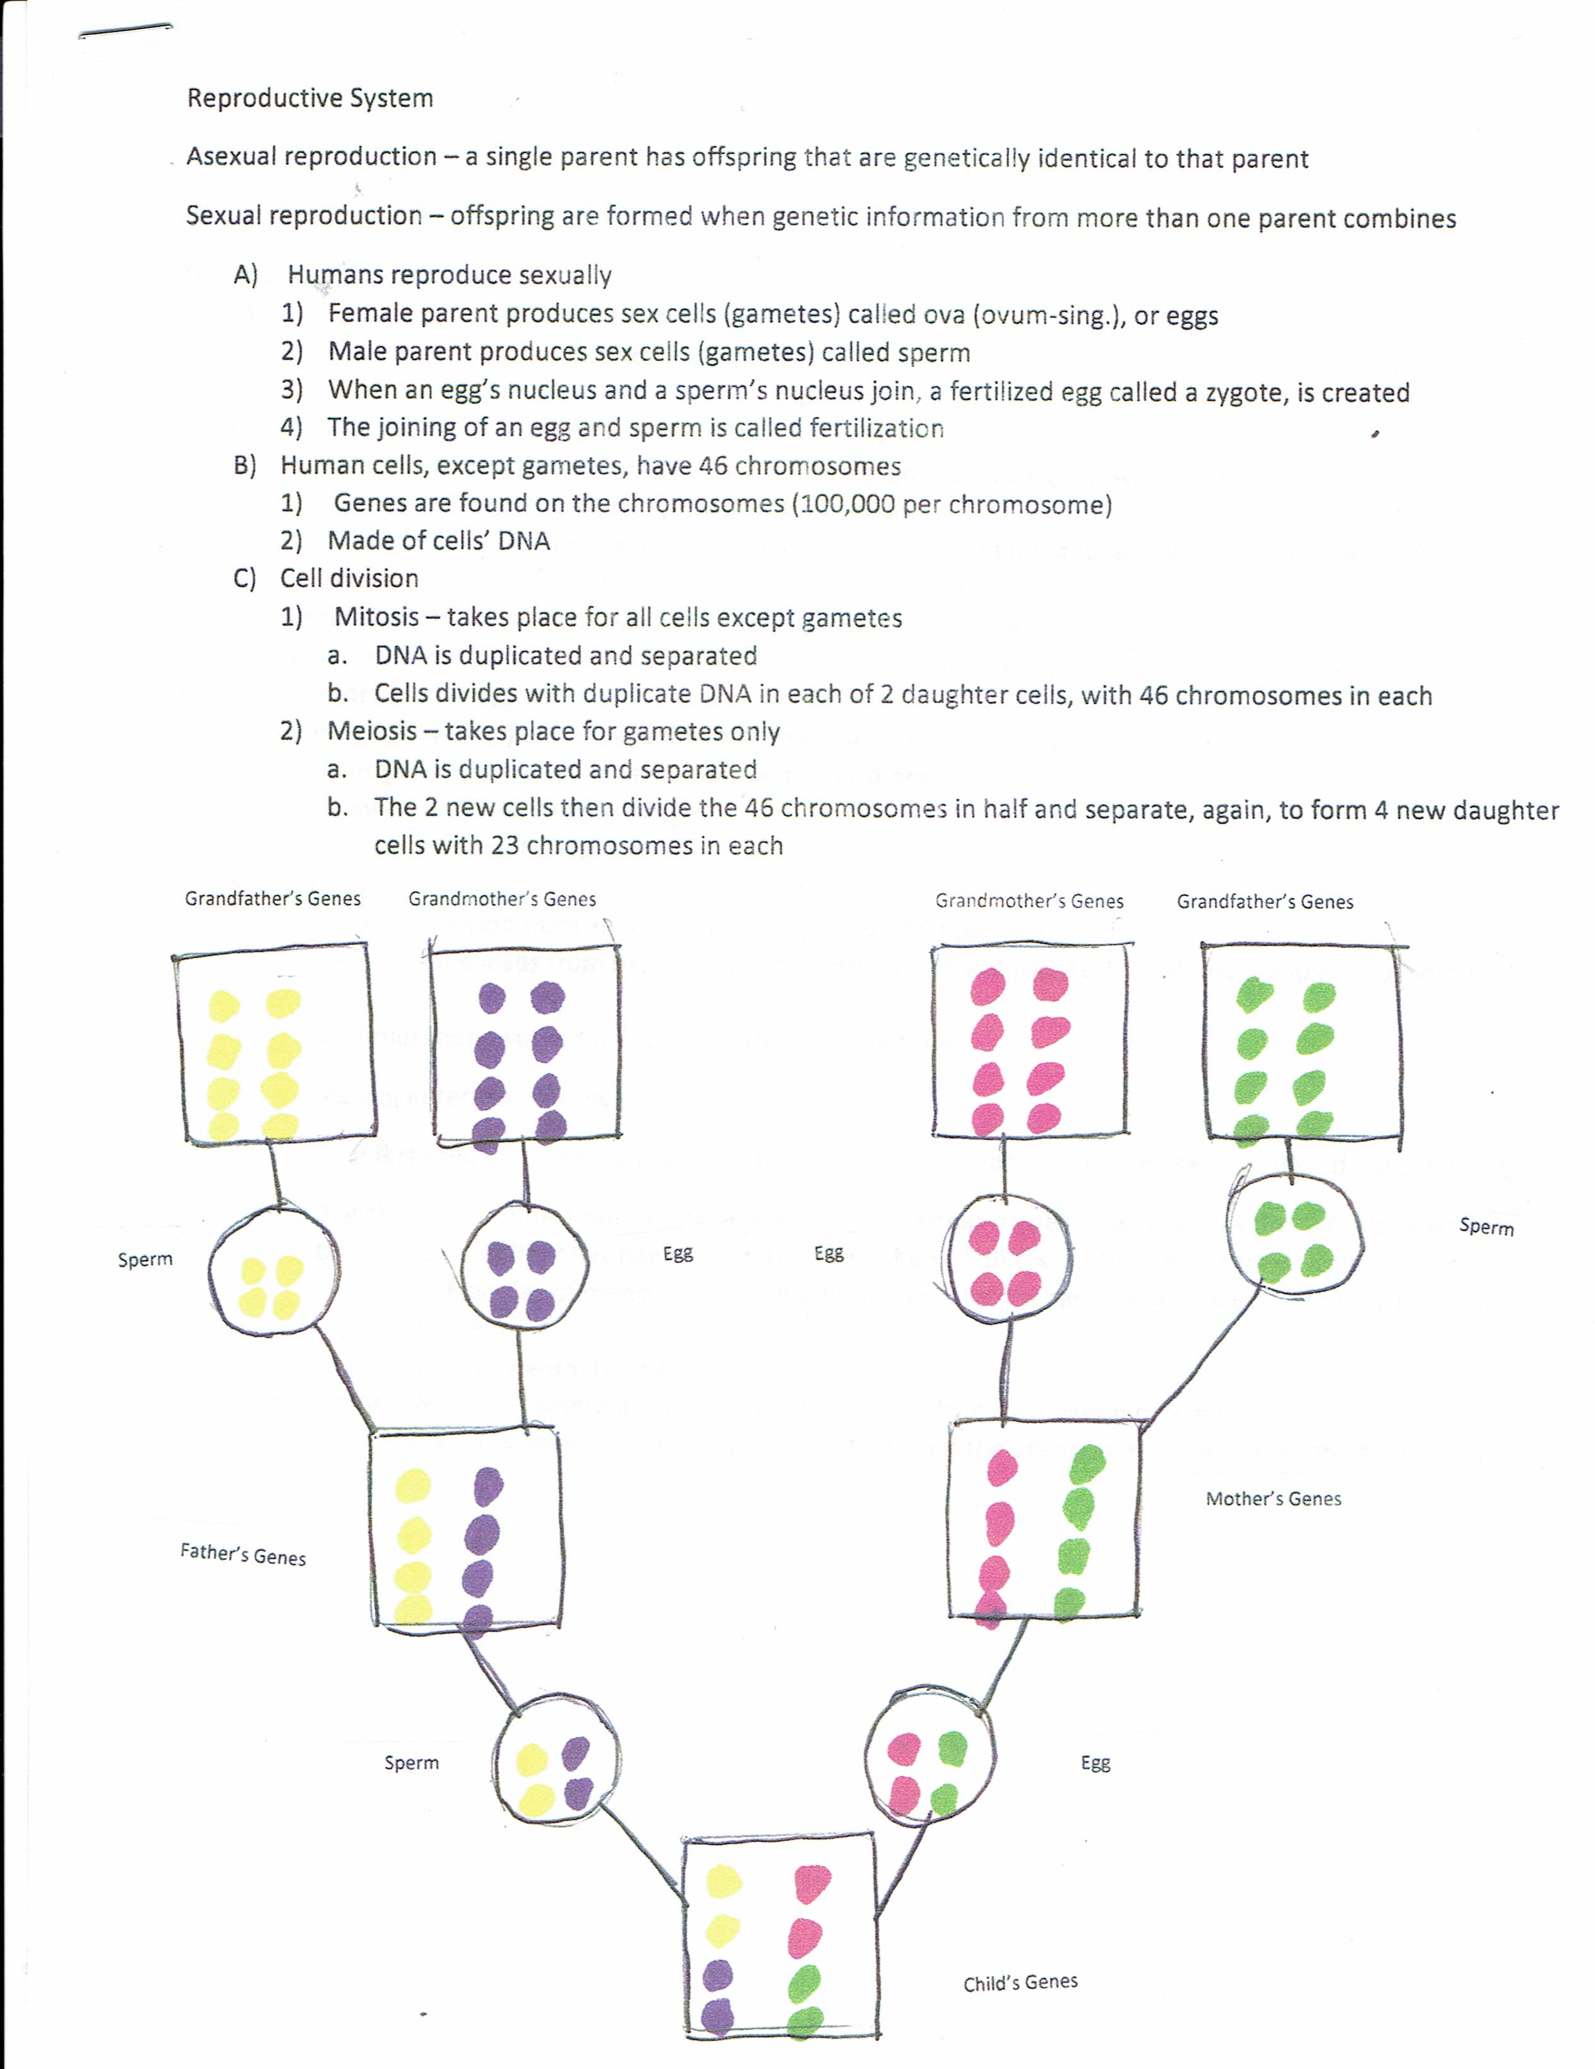
- Male reproductive system
- Testes – pair of organs that produce sperm and testosterone
  - Testosterone is the main male sex hormone
    - Helps regulate production of sperm
    - And development of male characteristics
- Sperm leave each testis and are stored in a tube called the epididymis, where they mature
- Vas deferens – a tube from the epididymis to the urethra
- Passes through the prostate gland and picks up fluid from prostate and several other glands forming semen (sperm and fluid)
- Urethra – tube that runs through the penis to the outside of the body
- Penis – external organ that transfers semen into the female’s body
- Female reproductive system
- Ovaries (ovary-sing.) two organs that make eggs and release estrogen and progesterone
  - Estrogen and progesterone are female sex hormones
  - They regulate the release of eggs
  - And development of female characteristics
2) Ovulation
a. An egg is released from an ovary and passes into a fallopian tube b. Fallopian tube leads from each ovary to the uterus. The egg passes through the fallopian tube into the uterus
1. fertilization usually takes place in the fallopian tube
c. The egg enters the uterus
1. if fertilized, it is called a zygote and may become imbedded in the thickened lining of the uterus
2. if the egg is not fertilized within a few days, menstruation begins and flushes the egg, along with blood and tissue that has been generated along the wall of the uterus. This process occurs monthly.
a) First day of menstruation is the first day of the discharge of the blood and tissue from the uterus
b) Fourteenth day is ovulation
d. uterus is the organ where a zygote develops into a baby over a period of 9 months
e. vagina is the canal between the outside of the body and the uterus, sometimes called the birth canal

